TESDA-OP-CO-04-F14
Rev.No.01-05/04/23

COMPETENCY ASSESSORS’ ACCREDITATION
CHECKLIST OF REQUIREMENTS

PO/DO | RO | Requirement | Remarks for RO
 |  | Letter of Intent
 |  | Accomplished Application Form with attached picture - passport size, white background, and with handwritten name and signature (TESDA-OP-CO-04-F16)
 |  | Transcript of Records
 |  | Picture, one (1) piece, 2” x 2”, white background and with handwritten name and signature
 |  | Certificate of Employment indicating compliance to the required number of years of relevant work/industry experience for the qualification as specified in the promulgated Training Regulations
 |  | National Certificate Level 2 or higher
 |  | Trainers Methodology Certificate (TMC) Level I or Certificate of Competency on Conduct Competency Assessment (TMI-COC2)
 |  | Certification on Loading (TESDA-OP-CO-04-F24) attested by the AC Manager, Lead Assessor, and the TESDA Representative that the applicant has assisted in the assessment to at least ten (10) candidates under the supervision of the Lead Assessor
 |  | For re-accreditation, Results of Performance Evaluation (TESDA-OP-CO- 05-F37) and Report on Assessment Proceedings (TESDA-OP-CO-05-F34)

Endorsed by:
(Name of Provincial/District Director)
Date:

Approved Disapproved

REMARKS:

(Regional Director)
Name of Region

TESDA-OP-CO-04-F15
Rev. No. 01-05/04/23

CERTIFICATION OF CONCURRENCE

I, ________(Name)_______, ____________(Designation/Position)___________ of _________________________(Name of Employer/Company)___________________ located at ______________________(address of Establishment)______________ hereby certify that I have fully understood and will abide by the requirements and procedures under the Accreditation of Competency Assessor outlined as follows:

- Accreditation Procedures;
- Requirements for Accreditation; and
- Accreditation Fee.

Done this ______ day of _______________ in the year _____________.

Signature
Position

Noted by:

Provincial Director
Date

TESDA-OP-CO-04-F16
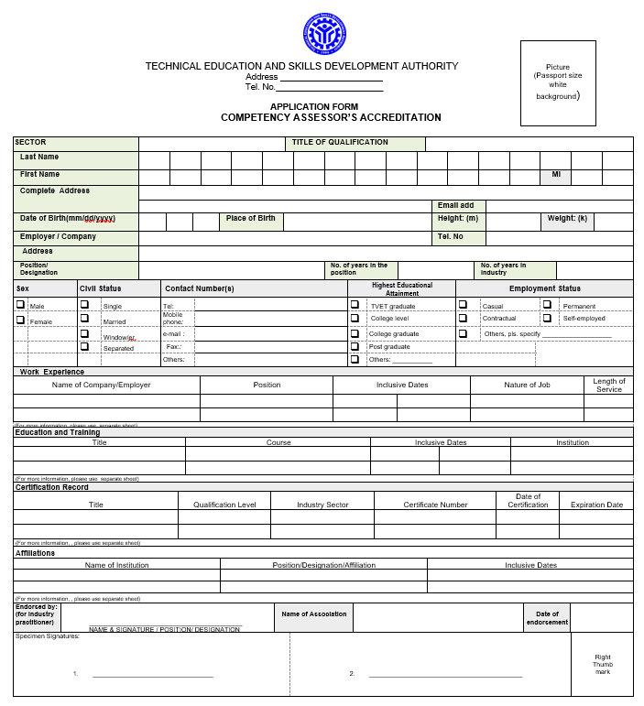
Rev.No.01-05/04/23

TESDA-OP-CO-04-F17
Rev. No. 01-05/04/23

LETTER OF NOTIFICATION
(Competency Assessor)

Date

Dear Mr. / Ms. ________________:

In connection with your application as competency assessor for (indicate the tile of qualification), we would like to inform you that:

- all your documents are in order
- the following documents are lacking
(List document(s) to be submitted/completed
____________________________________
____________________________________

Please visit our office on (indicate date and time) for the completion of the other requirements for accreditation. Failure to submit required documents within 48 hours shall imply disinterest.

Thank you very much.

Very truly yours,

_______________________
Provincial Director

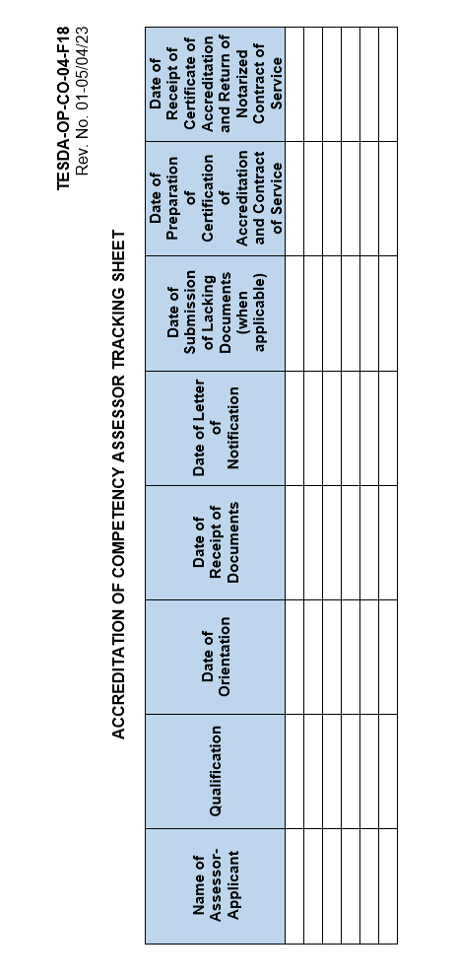

TESDA-OP-CO-04-F19
Rev. No. 01-05/04/23

TECHNICAL EDUCATION AND SKILLS DEVELOPMENT AUTHORITY

CERTIFICATE OF ACCREDITATION

This is to certify that

(Name of Assessor)

Is an Accredited Competency Assessor for

(Title of Qualification)

Accreditation No. ________________________

Date Accredited: 01 February 2015 Valid until: End of Validity of NC

Approved by: _________________________
Regional Director, (Name of Region)


TESDA-OP-CO-04-F22
Rev No. 02-05/15/24

________________________________
Signature over Printed Name of Competency Assessor

(TITLE OF QUALIFICATION)

Accreditation No. ______________

Date of Accreditation: __________ Valid until: ____________

___________________________
Regional Director, TESDA _____

TECHNICAL EDUCATION AND SKILLS DEVELOPMENT AUTHORITY
PHILIPPINE TVET COMPETENCY ASSESSMENT AND CERTIFICATION SYSTEM (PTCACS)

2” x 2” Picture
white background and
with handwritten name and signature

/////

TESDA-OP-CO-04-F24
Rev. No. 01-05/04/23

C E R T I F I C A T I O N

This is to certify that _______________________________________ has assisted in the assessment of ___________ candidates in ______________________ under the supervision of the National/Regional/Provincial/District Lead Assessor on _________________ at _____________________________.

This Certification is being issued in compliance to the requirements for accreditation as competency assessor in accordance with the provisions of the Operating Procedures on Accreditation of Competency Assessor (CA).
.

Given this ______ day of ________________ 20 ______ at ___________________________________, valid until (6 months after the date of issuance.

National/Regional/Provincial/District Lead Assessor |  | Assessment Center Manager |  | TESDA Representative

TESDA-OP-CO-04-F25
Rev. No. 01-05/04/23

NATIONAL LEAD ASSESSORS’ ACCREDITATION
CHECKLIST OF REQUIREMENTS

Requirements

- Resume / Curriculum Vitae;
- Certification issued by QSO that the Expert Panel Member served as expert in the development of Competency Standards / Competency Assessment Tools;
- Letter of endorsement from Industry Association or Partner Government Agency;
- Certificate of Employment indicating compliance to the requirements of number of years of industry experience as prescribed in the promulgated Training Regulations; and
- Trainer’s Methodology Certificate Level I or Trainer’s Methodology Certificate Level I – COC 2.

TESDA-OP-CO-04-F26
Rev No. 01-05/15/24

MEMORANDUM
(PO) No. ______ s. 20__

FOR | : | The Regional Director, (Region)
FROM | : | The Provincial/District Director, (Province/District)
SUBJECT | : | Endorsement of Application for Accreditation as Competency Assessor
DATE | : | (Day, Month, Year)

- References:

  - Competency Assessors’ Accreditation Checklist of Requirements (TESDA-OP-CO-04-F14);
  - Additional requirements (as applicable)

- This refers to the application of of Mr./Ms. _____________ as Competency Assessor for (indicate the title of qualification).

- As a result of the evaluation of the application documents of Mr./Ms. ____________, he/she complies with the requirements and has sufficient relevant industry/work experience as prescribed in the Training Regulations and Implementing Guidelines. In this regard, we recommend for the approval of his/her accreditation in (indicate the title of qualification).

- Attached are the complete documents as required in Section 6.1.3.2 of the Operating Procedure on the Accreditation of Competency Assessor (TESDA-OP-CO-04, Rev. No. 01-01/04/24).

_______________________
Provincial Director

TESDA-OP-CO-04-F27
Rev. No. 00-05/04/23

CONTRACT OF SERVICE

KNOWN ALL MEN BY THESE PRESENTS:

This Contract is made and entered by and between:

Technical Education and Skills Development Authority (TESDA), a government agency with office address at TESDA Administration Building, East Service Road, South Luzon Expressway (SLEX), Fort Bonifacio, Taguig City 1630, Metro Manila, represented by its Regional Director, __________________, hereinafter referred to as the “First Party”;
-and-

(NAME OF COMPETENCY ASSESSOR), of legal age, Filipino, single/married, and a resident of ________________________________, hereinafter referred to as the “Second Party;”
WITNESSETH

WHEREAS, that the First Party engage the services of the Second Party as Competency Assessor in (TITLE OF QUALIFICATION) to be assigned to a duly Accredited Assessment Center/Designated Assessment Venue;

WHEREAS, that the First Party to provide opportunity for the Second Party to participate/attend in Calibration/Moderation Program on the Conduct of Competency Assessment for the Qualification to ensure standard method of conducting quality-assured assessment;

WHEREAS, that the Second Party possesses the required industry work experience, skills, and knowledge to perform the job described herein;

NOW THEREFORE, in consideration of the above Recitals, and the mutual promises made herein, both Parties further agree as follows:

Section 1: The Second Party agrees that aside from the Assessor’s Fee, no additional monetary and non-monetary benefits shall be provided by the First Party and Assessment Center/Designated Assessment Venue;

Section 2: No employee-employer relationship exists between the First Party and the Second Party;

Section 3: The Second Party hereby attests that she/he is not related within the third civil degree of consanguinity or affinity to the First Party, and/or its duly authorized representative.

Section 4: The following are the duties and responsibilities of the Second Party:

- Participate/Attend the Calibration/Moderation Program on the Conduct of Competency Assessment for the Qualification as required by TESDA.

- Conduct competency assessment through the established procedures, to wit:

  - Plan and organize
    - Establish the assessment context and purpose of assessment
    - Plan and prepare the evidence gathering process

  - Assess competence
    - Prepare the candidates
    - Collect evidences

  - Make the assessment decision
    - Evaluate evidence
    - Record the assessment outcome
    - Review the assessment decision
    - Accomplish the CARS

  - Provide feedback on the assessment
    - Provide the candidate feedback
    - Ensure that the Rating Sheets and CARS are signed
    - Submit Rating Sheets and CARS to the AC Manager

  - Record and report the assessment results on the day of the assessment activity
    - Review necessary assessment reports
    - Return assessment-related documents to the TESDA Representative
    - Ensure that assessment results have been recorded accurately
    - Sign the Registry of Workers Assessed and Certified (RWAC)
    - Submit complete set of assessment-related documents to the AC Manager

- Comply with the following responsibilities, terms, and conditions:

  - Provide quality competency assessment for candidates in (TITLE OF QUALIFICATION).
  - Inspect the completeness and adequacy of the assessment facilities of the assessment center, tools, equipment, supplies and materials to comply with all the assessment requirements;
  - Conduct the assessment strictly following the Competency Assessment Tools (CATs) and the rules and regulations in the Operating Procedures on Competency Assessment and other assessment-related issuances;
  - Verify the identity of the candidate through any Government-issued Identification Card with picture, birth date, and signature, that the candidate who is supposed to take the assessment is the same person as shown in the Application Form, and Admission Slip;
  - Safeguard/Ensure the authenticity, validity, and confidentiality of all documents pertaining to the conduct of competency assessment, most importantly the CATs and shall never involve his/her self in the unauthorized use of the same through reproduction, distribution, circulation, and/or deliberate disclosure of the content;
  - Conduct the competency assessment strictly within the premises of the assessment center or designated assessment venues only;
  - Submit the correct assessment results and reports immediately after the conduct of assessment;
  - Assume full responsibility for ensuring the objectivity and integrity of assessment activities;
  - Cooperate with TESDA auditors while conducting compliance audit; and
  - Avoid involvement with any “conflict of interest” activity related to assessment and certification program, e.g., Placement/Recruitment Agency, Review Center, among others.

Section 5: The Second Party shall not participate in any transaction involving graft and corruption. Otherwise, the Second Party shall be criminally and/or civilly liable in accordance with pertinent rules and regulations.

The Second Party agrees to be paid by the Accredited Assessment Center with the Assessor’s Fee indicated in the latest Promulgated Assessment Fees approved by the TESDA Board;

Section 6: That for purposes of this Contract, “Confidential Information” means any information furnished to a party by the other party hereto pursuant to this Contract which if disclosed in tangible form is marked “Confidential” or with other similar to indicate its confidential or proprietary nature, or if disclosed orally to be confidential or proprietary by the party disclosing such as information at the time of the initial disclosure thereof and is confirmed in writing as confidential or proprietary by the disclosing party with ten (10) business days after such disclosure, or which a reasonable person would recognize to or for the furtherance of this Contract that has or could have commercial value or other utility in the business or prospective business of the disclosing party. Confidential information shall not, however, include any information which, in each case as demonstrated by the sufficient evidence: (i) was publicly known and made generally available in the public domain prior to the time of disclosure by the disclosing party; (ii) becomes publicly known and may generally available after the disclosure by the disclosing party to the receiving party through no action or inaction of the receiving party; (iii) is already in the possession of the receiving party at the time of disclosure by the disclosing party; (iv) is obtained by the receiving party’s obligations of confidentiality or (v) is independently developed by the receiving party without use or reference to the disclosing party’s Confidential Information”.

That the Second Party hereby agrees that during the engagement as Accredited Competency Assessor, he/she shall not, at any time or in any manner, divulge, disclose or communicate to any non-TESDA related entity, person, agency, firm or establishment in any manner whatsoever any confidential information that he/she may have learned or known in the course of her/his engagement;

In pursuant thereof, the Second Party hereby agrees to execute a Non-Disclosure Agreement;

Section 7: This Contract shall be valid and effective upon signing thereof until the expiration of the National Certificate. Either Party may terminate the contract due to reasonable cause/s provided that a written notice is sent within ten (10) calendar days prior to the intended date of termination. Further, the termination of the contract shall be without prejudice to the obligations already incurred.

Section 8: The liability of the Second Party for any breach of this contract shall be determined in accordance with the sanctions and penalties imposed in TESDA Circular No. 134, Series of 2019 or the applicable TESDA rules and regulations regarding assessment and certification.

IN WITNESS WHEREOF, both Parties have hereto set their hands this ___ day of _______________, 20__ at ___________________.

(NAME OF REGIONAL DIRECTOR)  Regional Director  Region ____ |  | (NAME OF COMPETENCY ASSESSOR)  Competency Assessor
SIGNED IN THE PRESENCE OF:
(NAME OF ROD CHIEF)  TESD Specialist, Region ___ |  | (NAME OF REGIONAL CAC FOCAL PERSON)  CAC Focal Person, Region ___

ACKNOWLEDGEMENT

REPUBLIC OF THE PHILIPPINES)
____________________________) S.S.

BEFORE ME, a Notary Public for and in the Province/City of ____________ this __________________ 20____ personally came and appeared:

NAME | VALID ID NO. | ISSUED BY
(NAME OF REGIONAL DIRECTOR)
(NAME OF COMPETENCY ASSESSOR)

Known to me and to known to be the same persons who executed the foregoing instrument which they acknowledge before me as their free and voluntary act and deed.

This instrument consists of five (5) pages including this page wherein this Acknowledgement is written, and is signed by the Parties and their instrumental witnesses on each and every page hereof.

WITNESS MY HAND AND SEAL this ______ day of ________ 20___ at _______________________.

Doc. No. ________
Page No. ________
Book No. ________
Series of ________

TESDA-OP-CO-04-F28
Rev. No. 00-05/04/23

COMPETENCY ASSESSORS’ COMMITMENT FORM

By signing this Commitment Form, I agree to adhere to the following requirements for the conduct of Capability Building Program for Prospective Lead Assessors for (indicate title of Qualification):

- Fully engage in the training by committing adequate time, energy, and enthusiasm throughout the program;

- Serve as Competency Assessor (CA) if successfully passed the competency assessment in (indicate title of Qualification); and

- Conduct myself in a professional manner at all times during the conduct of assessment.

Should I be unable to comply with the terms and conditions listed above, I will refund the corresponding training cost as well as the travelling expenses.

Signature over Printed Name of Prospective Lead Assessor |  | Date

TESDA-OP-CO-04-F29
Rev. No.00-05/04/23

PERFORMANCE EVALUATION INSTRUMENT
(To be accomplished by Candidates)
Assessor’s Name
Qualification
Name of Respondent |  |  |  |  | Date  Accomplished
INSTRUCTIONS: Put a tick (✓) mark in the appropriate column
SCALE GUIDE | 5– Very Satisfactory  4 – Satisfactory |  | 3 – Good  2 – Fair |  |  |  | 1 – Poor
ITEM |  |  |  |  |  |  | RATING
 |  |  |  |  |  |  | 5 |  | 4 | 3 | 2 | 1
- Physical appearance and composure
(Pangkalahatang anyong pisikal at kung paano magdala sa sarili)
- Provided clear and concise instruction that is easily understood by the candidates
(Nagbigay ng malinaw at maigsi na instruction na madaling maintindihan ng mga candidates.)
- Established good rapport and communication with candidates
(Nagpakita ng magandang kaugnayan at maayos na pakikipag-usap sa mga candidates)
- Provided clear answers to queries and/or comments from the candidates
(Nagbigay ng malinaw na mga sagot sa mga katanungan at komento mula sa mga candidates)
- Exhibited respectable behavior
(Nagpakita ng kagalang-galang na pag-uugali)
- Explained the purpose and scope (context) of assessment
(Ipinaliwanag ang layunin at saklaw (konteksto) ng assessment.)
- Provides fair, reliable and valid assessment decision (Kakayahang magbigay ng pantay, ugma at tamang desisyon sa resulta ng pagsusulit)
Sub - score
FINAL RATING
Signature of Respondent

 | FOR TESDA USE ONLY
EVALUATOR’S REMARKS:
 | RECOMMENDATION:
 | For re-accreditation | ❑ YES  ❑ NO | ❑ For further review
*Shall be accomplished by two (2) candidates per assessment schedule. The candidates shall be 1 Competent and 1 Not Yet Competent
TESDA-OP-CO-04-F30
Rev. No. 00-05/04/23

PERFORMANCE EVALUATION INSTRUMENT
(To be accomplished by the AC Manager)

Assessor’s Name
Qualification
Name of Respondent |  |  |  |  | Date  Accomplished
INSTRUCTIONS: Put a tick (✓) mark in the appropriate column
SCALE GUIDE | 5– Very Satisfactory  4 – Satisfactory |  | 3 – Good  2 – Fair |  |  |  | 1 – Poor
ITEM |  |  |  |  |  |  | RATING
 |  |  |  |  |  |  | 5 |  | 4 | 3 | 2 | 1
- Planned and prepared the evidence gathering process
(Nagplano at naghanda ng proseso ng pangangalap ng ebidensya para sa assessment)
- Provided allowable/reasonable adjustments in the assessment procedure
(Nagbigay ng mga konsiderasyon/makatwirang pagsasaayos sa pamamaraan ng assessment)
- Collected appropriate evidence during the conduct of assessment
(Nangalap at sumuri ng mga tamang ebidensya habang nagbibigay ng assessment
- Provided clear and constructive feedback on the assessment decision
(Nagbigay ng malinaw at tamang kaukulang opinyon sa resulta ng assessment)
- Provided fair, reliable and valid assessment decision (Kakayahang magbigay ng pantay, ugma at tamang desisyon sa resulta ng pagsusulit)
Sub - score
FINAL RATING
Signature of Respondent

 | FOR TESDA USE ONLY
EVALUATOR’S REMARKS:
 | RECOMMENDATION:
 | For re-accreditation | ❑ YES  ❑ NO | ❑ For further review
*Shall be accomplished by the AC Manager per assessment schedule.

TESDA-OP-CO-04-F31
Rev. No. 00-05/04/23

COMPETENCY ASSESSORS’ CREDO

I believe in the integrity, credibility and prestige of the Philippine TVET Competency Assessment and Certification System, hence:
- I will administer competency assessments strictly in accordance with the guidelines set forth in the system’s competency assessment methodologies.
- I will be professional in all my dealings with the competency assessment candidates, to maintain the objectivity and highest standards of service I render as an assessor.

I believe in every candidate’s right to total concentration during the assessment, hence:
- I will never express demeaning words to the candidates and will treat them with utmost respect.
- I will provide and maintain an environment conducive for the candidates to feel relaxed and undistracted during the assessment.

I believe in the sanctity of the competency assessment tools, hence:
- I shall zealously safeguard the competency assessment instruments from any form of leakage or circulation.
- I shall see to it that nobody else has access to instrument materials except members of the TESDA competency-assessment team and accredited/authorized persons.

Last but not the least, I shall not allow the competency assessment to be an instrument for corruption.

So help me, God.

TESDA-OP-CO-04-F32
Rev. No. 00-05/04/23

NON-DISCLOSURE AGREEMENT
ACCREDITED COMPETENCY ASSESSOR

I, (NAME OF ACCREDITED COMPETENCY ASSESSOR), acknowledge that, service with the Technical Education and Skills Development Authority (TESDA), I will have access to materials of a confidential and/or proprietary nature. “Confidential” and “proprietary” materials include, but are not limited to:

- Information about applicants’, candidates’, and certified persons personal and financial data;
- Information submitted for investigations of alleged violations of the Code of Ethics;
- Item content, characteristics, development, or other aspects of a test;
- Assessment/Examination and forms;
- Corporate and certification documents; and
- Financial data.

Therefore, I agree to the following conditions of service:

- I will abide by all certification policies and procedures for proper handling and security of confidential and proprietary materials;

- I will not disclose any confidential or proprietary materials to any unauthorized individual or organization unless expressly authorized by the TESDA;

- I will not remove any confidential or proprietary materials from the Accredited Assessment Centers and TESDA premises unless so directed by a TESDA authorized person and I will safeguard such materials, as directed, until they are delivered or returned;

- I will hold examination content in confidence perpetually and will not disclose, publish, reproduce, summarize, paraphrase, or transmit examination content, in whole or in part, in any form or by any means, oral or written, electronic or mechanical, for any purpose.

I understand and agree that the unauthorized disclosure of confidential or proprietary material could cause harm and irreparable damage to the certification program that may be difficult to ascertain. Accordingly, I agree that TESDA shall have the right to seek and obtain immediate injunctive relief from material breaches of this agreement, in addition to any other remedies at law available and therefore without bond.

I understand that TESDA shall impose sanctions and penalties such as revocation of all of my accreditation as Competency Assessor, cancellation of all of my National Certificates, Trainer’s Methodology Certificate, and all National TVET Trainer Certificate, and perpetual disqualification to apply for accreditation/re-accreditation if I committed a material breach of the terms and condition contained in the agreement. The obligations under this agreement shall continue perpetually and survive the termination or expiration of my accreditation or service.

I agree that this agreement shall be construed in accordance with the laws of the Republic of the Philippines.

I voluntarily and willingly executed this Non-Disclosure Agreement.

IN WITNESS WHEREOF, I have hereto affixed my signature this _____ day of ________________, 20_____ in __________________, ___________, Philippines.

(Name of Competency Assessor)
Affiant
Government Issued ID
ID No.
Date Issued

SUBSCRIBED AND SWORN to before me, this _____ day of ________, 20____, affiant exhibiting to me the above-stated government-issued identification card.

NOTARY PUBLIC

Doc. No.
Page No.
Book No.
Series of

TESDA-OP-CO-05-F34
Rev. no. 00-03/08/17

REPORT ON ASSESSMENT PROCEEDINGS

Name of Competency Assessment Center
Accreditation Number
Title of Qualification
Date of Assessment |  |  |  | No. of Candidates
Name of Competency Assessor(s)
Findings and Observations:
Items |  | Yes | No |  | Areas for Improvement
1. Competency Assessor has a signed Letter of Appointment
2. Attendance of the candidates is checked and Admission Slips are verified and collected
3. Supplies and materials are available during the conduct of assessment
4. Tools and equipment are available and in good working conditions
5. Assessment starts on time
6. Conduct of assessment is in accordance with the methods identified in the CATs
7. Projects produced by the candidates are in accordance with the requirements in the CATs.
8. Candidates are provided with clear and constructive feedback on the assessment decision (one-on-one)
9. Assessor has the ability to manage the competency assessment proceedings
10. Complaints of candidates are properly addressed and handled by the Assessor & the AC, when applicable
11. Assessment Packages issued to the Assessor are completely returned upon completion of assessment
- Assessment-related documents are accurately accomplished and submitted promptly after assessment
  - Rating Sheets
  - CARS
  - Attendance Sheet
  - RWAC
  - Applications Forms with SAGs
  - Assessor’s Guide & Specific Instruction to Candidate
Narrative: (Recommended areas for improvement of items which are not covered or listed above)
Prepared by:  /  Signature over Printed Name (TESDA Rep) |  | Date:

